Aim: Impement Query monitor for different types of joins.

Theory: A query monitor in databases like MySQL is used to track, analyze, and optimize the execution of SQL queries. Its main purpose is to provide visibility into the queries being executed on the database, helping database administrators (DBAs) and developers identify issues related to performance, efficiency, and resource usage.

Selection operation:

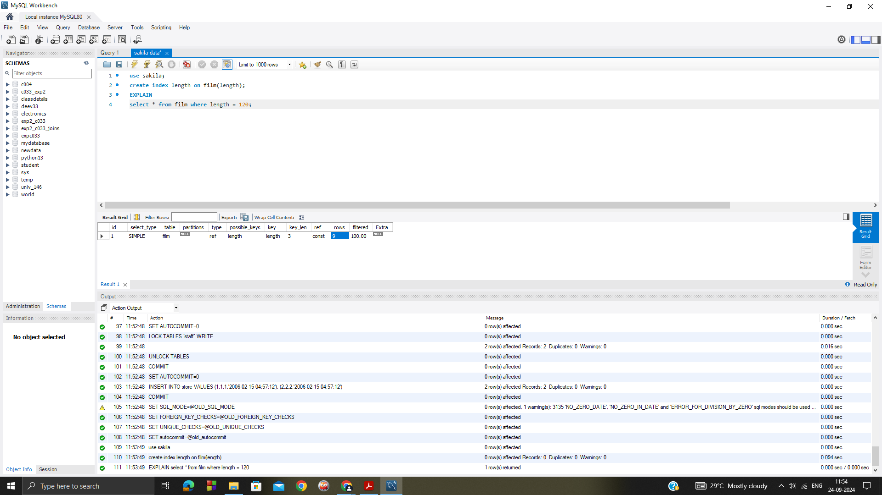

Nested :

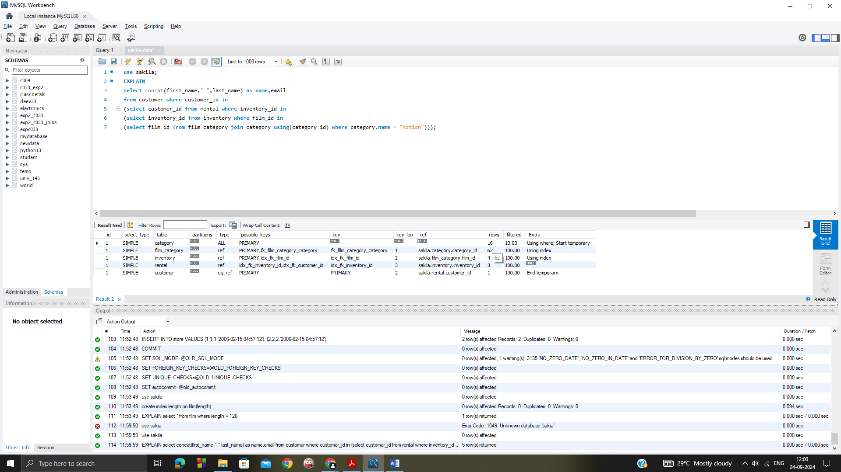

Left join :

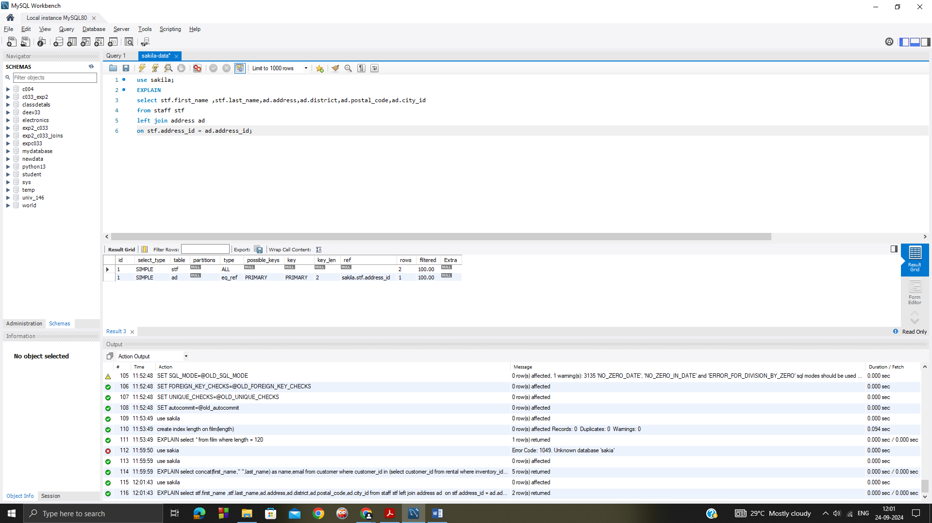

Right join :

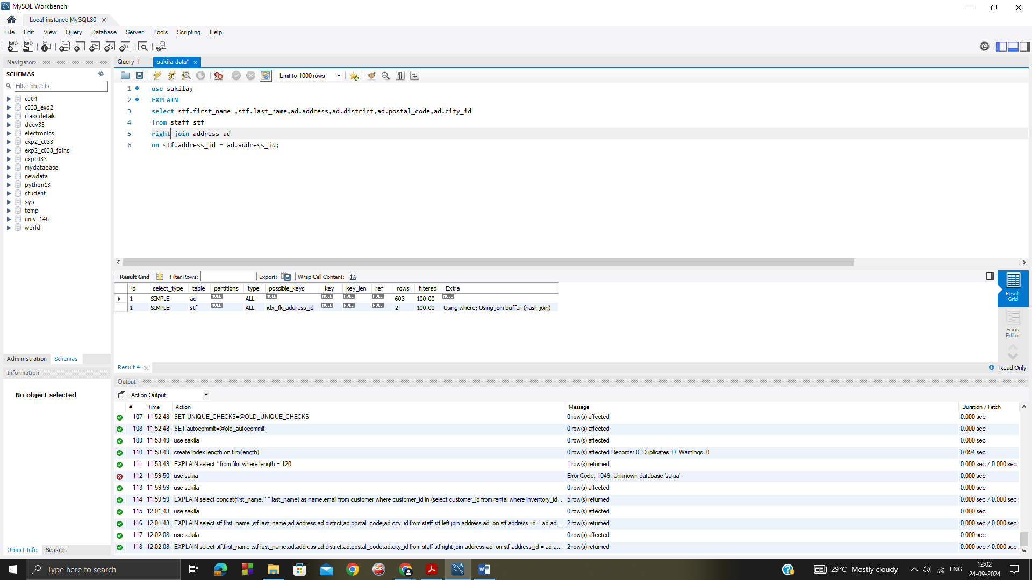

Inner join:

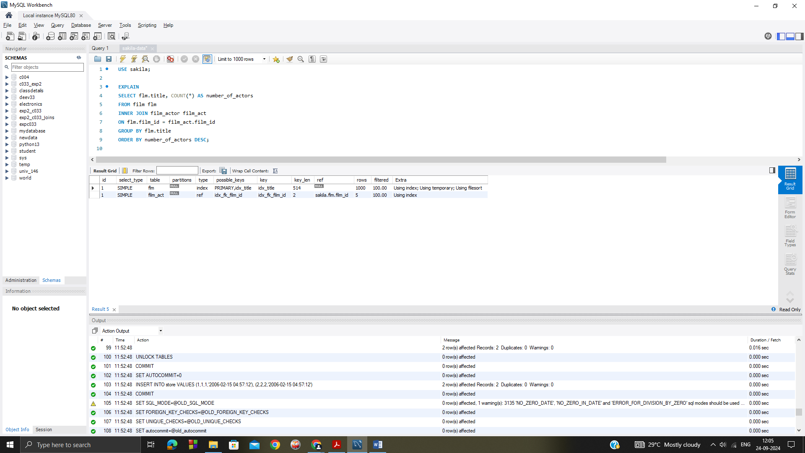

Conclusion : *Successfully implemented Query monitor feature for different types of join operations in Mysql Workbench.*